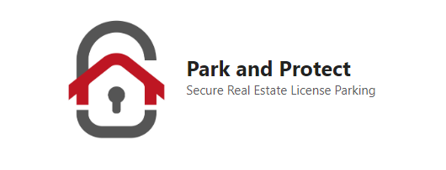

Date:______________________

In accordance with the requirements of the **Real Estate Council of Alberta**, this form serves as acknowledgement and disclosure for a registered professional with **Park and Protect** to share personal information of a consumer with another industry professional, business, or agency for the benefit of the consumer. Information to be shared may include the following: consumers name, phone number, email, contact information, or other directly relevant personal information of material relevance.

**Park and Protect** brokerage and its registered agent may on occasion receive compensation or benefit resulting from the professional referral of consumers to other professional service providers, a typical example of such compensation would be a professional referral fee. At all times, we hold client information with the utmost privacy and always act in our consumers best interests. **By signing below all parties consent to and acknowledge the sharing of personal information for the purposes of making a professional referral for the benefit of the consumer and upon which a referral fee may be paid.**

Park and Protect registered representative:

Name:______________________________________

Signature:___________________________________

Consumer being referred:

Name:______________________________________

Signature:___________________________________

Email:______________________________________