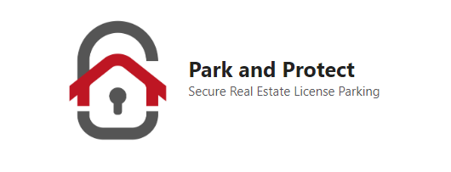

Date:______________________

CUSTOMER REFERRAL TO:_______________________________________________

In accordance with the requirements of the **Real Estate Council of Alberta**, this form serves as acknowledgement for a registered professional with **Park and Protect** to share personal information of a consumer with another industry professional, business, or agency. Information to be shared may include the following: consumers name, phone number, email, contact information, or other directly relevant personal information of material relevance.

**Park and Protect** brokerage and its registered agent are acknowledged to be eligible to be paid a referral fee as described below as compensation for this referral, upon successful completion of a transaction between the referred client and the recipient of the referral. Park and Protect has fulfilled our disclosure to the customer. All referral fees shall be forwarded directly to Park and Protect within 14 days of transaction completion. By signing, the referral is deemed to have been sent, received and accepted.

**Referral Fee Details:_____________________________________________________________________**

Park and Protect registered representative:

Name:______________________________________

Signature:___________________________________

Consumer being referred:

Name:______________________________________

Signature:___________________________________

Email:______________________________________

Confirmation of Referral Received:

Authorized by:_______________________________

Company:___________________________________